**ASSIGNMENT - 2**

**News Tracker Application**

|  |  |
| --- | --- |
| Date | 13 October 2022 |
| Team ID | PNT2022TMID04471 |
| Project Name | Project - News Tracker Application |
| Maximum Marks | 4 Marks |

1. Run a flask app

Successfully installed flask framework and run an app using flask.

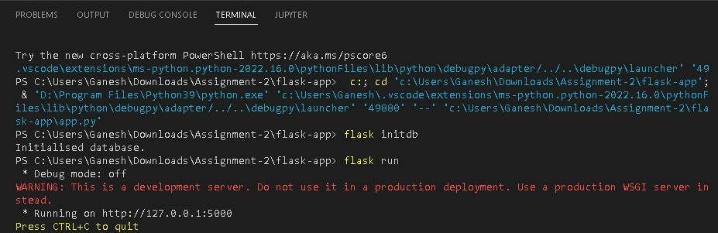

1. Add the home page



1. Add the Sign in page

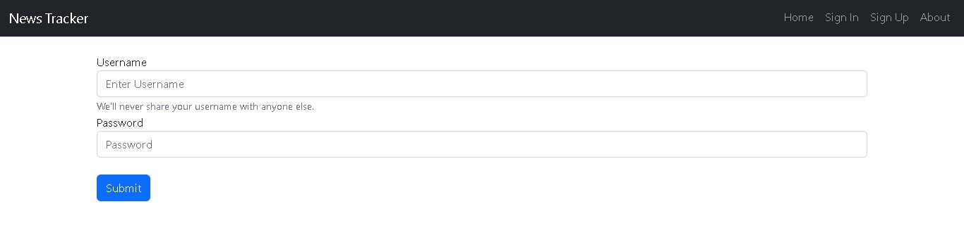

1. Add the Sign up page

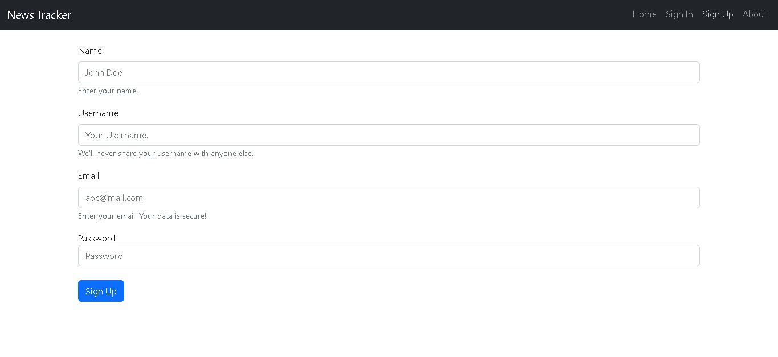

5.Add the about page